Final Exam Portfolio
This portfolio documents the learning journey undertaken throughout ITAI 1370 – Artificial Intelligence Hist. Across twelve modules, I engaged with a wide spectrum of AI topics: from the historical foundations of the field to hands-on experimentation with neural networks, natural language processing, computer vision, and generative models. Each section below captures what I did, what I produced, and most importantly what I learned.

Module 1 Introduction to A.I. - Course Setup
- L01
This module’s assignment introduced the conceptual foundation of modern AI through a video lecture “Trinity of Artificial Intelligence” by Dr. Anima Anandkumar, a well-known AI researcher and professor. She identifies three essential ingredients that power today’s AI systems: data, algorithms, and computer infrastructure. Without any one of these, cutting-edge AI would not be possible.
Dr. Anima opens with an instructive comparison: a Boston Dynamics Atlas robot executing a perfectly programmed backflip versus a dog learning the same movement through experience and feedback. The robot is impressive, but it is pre-programmed, so it does not truly learn. The dog demonstrates genuine intelligence by adapting. This contrast frames the central challenge of AI: building systems that can generalize, not just memorize.
The three pillars she describes are deeply interconnected:
- Data: The role of large, labeled datasets (e.g., ImageNet with millions of categorized images) give models the raw material to learn from. Without diverse, high-quality data, even the best algorithm produces poor results.
- Algorithms: Deep learning algorithms using stacked neural network layers, allow models to transform raw data into learned representations. Each layer extracts increasingly abstract features.
- Computing Infrastructure: GPUs with billions of transistors enable the parallel matrix calculations that deep learning requires. Without this hardware revolution, modern AI would remain computationally infeasible.
The most striking insight from this module’s assignment was Dr. Anima’s caution: reaching human-level accuracy on a benchmark dataset (like ImageNet) does not mean AI has achieved human-level intelligence. Generalization, the ability to apply learned knowledge to genuinely new situations, remains an open and difficult problem. This taught me to think critically about AI benchmarks: a high accuracy score on a test set tells us something, but not every, about true capability.
Module 2 Introduction to A.I. - The Big Issues
- Assignment A02 (L02)
On November 30, 2022, OpenAI CEO Sam Altman posted a simple tweet announcing ChatGPT’s launch. Within five days, one million people had signed up. By January 2023, the number had reached 100 million monthly users, which was the fastest user adoption of any consumer application in history.
What made ChatGPT transformative was not the underlying technology (GPT-3.5 had existed since 2020) but the interface. For the first time, anyone with an internet connection could type a plain-language question and receive a coherent, nuanced response with no technical background required. This democratized access to AI overnight.
Before ChatGPT (pre-Nov 2022)
- AI locked behind technical barriers
- Limited to developers and researchers
- Primarily research and specialized apps
- AI seen as “future technology”
- <10% of knowledge workers used AI
- Gradual AI development, no urgency
After ChatGPT (2023-2026)
- Accessible via simple chat interface
- Anyone with internet can use free AI
- Writing, coding, learning, creativity
- AI as everyday work and life tool
- 43% of knowledge workers use AI
- AI arms race; billions in investment
Google’s “code red” warning, Microsoft’s $10B investment in OpenAI, and Meta’s accelerated AI development all trace directly to November 2022. By 2026, ChatGPT has approximately 800 million weekly active users. The lesson I drew from this module: accessibility creates impact, but impact creates responsibility. The same openness that empowered millions of users also introduced risks of misinformation, academic dishonesty, and over-reliance, are challenges that educators and policymakers are still working to address.

Module 3
- Lab L03 – AI Game Master – Designing Training Grounds for Intelligent Systems
This lab assignment asked us to design a game that could train an AI system, using IBM Watson’s Jeopardy! Performance as a case study. This required thinking from the AI designer’s perspective: what game properties make a training environment effective?
Jeopardy! Presented unique challenges that made it a far richer AI problem than chess. First, it required natural language understanding where questions are phrased in indirect, idiomatic English, and answers must be inferred from context. Second, the answer-before-question format inverted conventional retrieval. Third, the buzzer mechanic added a real-time strategy layer: buzzing too early locks you out; too late and an opponent steals the question.
Watson’s surprising strategies demonstrated that AI learns differently from humans. Rather than using intuition, Watson leveraged mathematical probability at every decision point: it jumped around the board to find Daily Doubles, used calculated wagering instead of gut feeling, and adjusted buzzer confidence based on its real-time score differential. These were behaviors no human coach designed – Watson discovered them through training.
Applying the principles from Watson’s design, I created a concept for an AI Customer Service Simulator – a game whose purpose is to train a conversational AI agent to handle real customer interactions. The design was structured around four requirements that any effective AI training game must satisfy:
- Meaningful Choices: Every decision must teach a transferable skill. In the simulator, the AI chooses how to greet customers, selects response tone (friendly vs. professional), decides whether to ask follow-up questions, and determines when to escalate to a human agent. Each choice maps directly to a real-world customer service competency.
- Escalating Complexity: Training must start simple and grow harder. Level 1 presents basic FAQ questions. Level 2 introduces multi-step problems. Level 3 adds angry or confused customers. Level 4 combines conflicting information with time pressure. This scaffolded difficulty mirrors how human professionals develop skill over time.
- Measurable Progress: The game tracks customer satisfaction score, accuracy rate, response time, and escalation frequency. Without measurable metrics, there is no feedback signal for the AI to optimize.
- Safe Failure Space: All interactions are simulated and no real customers are harmed by a mistake. The AI can replay any scenario to learn from errors. This is the property that makes games so powerful as AI training environments: failure is informative, not catastrophic.
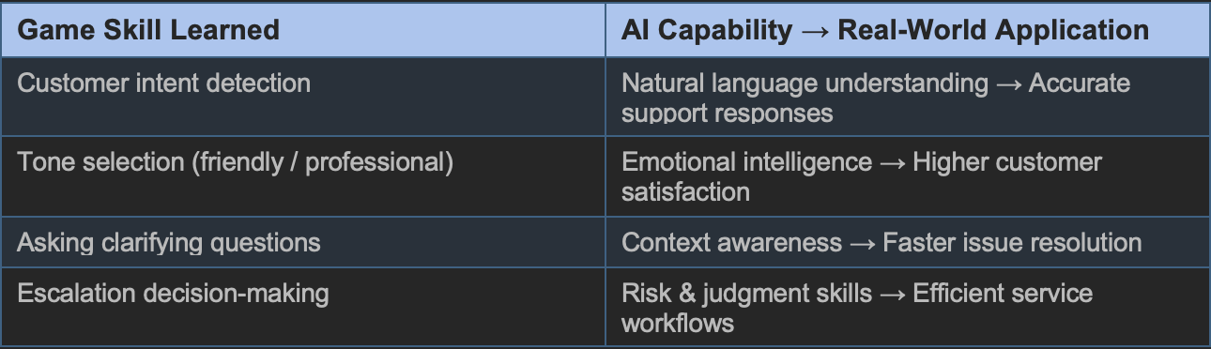

Module 4 Games Change Everything
- P04
A QR (Quick Response) code is a two-dimensional barcode invented in 1994 by Masahiro Hara at Denso Wave. Unlike linear barcodes, QR codes encode data both horizontally and vertically using a matrix of black and white squares, enabling storage of thousands of characters. Structural elements include positioning markers (at three corners), alignment patterns, timing patterns, and an error-correction mechanism that allows the code to function even if up to 30% of its area is damaged.
A traditional one-dimensional barcode encodes data in the widths of parallel black bars and white spaces. Optimized for high-speed, high-volume scanning in retail and logistics, barcodes store 20-100 characters – enough for a product SKU, but not for a URL or multimedia link. They require directional scanning and laser readers and provide no error correction.
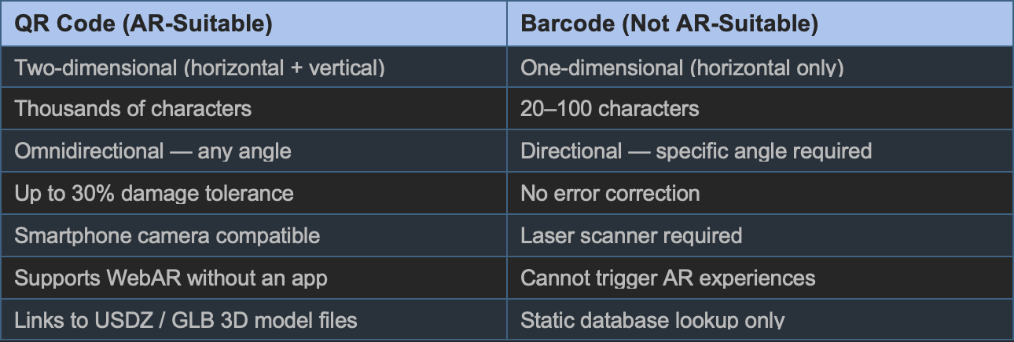
QR codes are unambiguously more suitable for AR applications. Their high data capacity allows them to encode full URLs or even AR file paths. Omnidirectional scanning makes them easy to use with smartphone cameras. Advanced error correction ensures reliability in real-world conditions (damaged, partially obscured). Traditional barcodes, while indispensable in retail and logistics, lack every technical property that AR requires.
- A04
Raytracing is a rendering technique that simulates how light behaves in the real world to produce photorealistic 3D images. Rather than simulating every photon from every light source (which would be impossible slow), it reverses the process: virtual rays are fired from the camera through each screen pixel into the 3D scene. When a ray strikes an object, the algorithm calculates reflections, refractions (bending through glass), and absorption, which all governed by physical optics.
For decades, raytracing was limited to offline rendering, film studios and visual effects houses where computers could spend hours or days per frame. Early feature films that used intensive path tracing (a subset of raytracing) include Monster House (2006), Cloudy with a Chance of Meatballs (2009), and Monsters University (2013). The technique was simply too computationally expensive for real-time applications
- Real-Time Gaming: NVIDIA and AMD developed dedicated GPU hardware for raytracing (RT cores). In 2018, Electronic Arts released Battlefield V, the first consumer game to feature real-time raytracing, marking a turning point for the industry.
- Architecture and Product Design: Architects and engineers use ray-traced renders to accurately preview how light and shadows will behave in spaces before construction begins.
- Medical Imaging: Volume ray casting renders 3D medical scans (CT, MRI) into interpretable visualizations for clinicians.
- Audio: Raytracing principles can simulate sound-wave propagation, producing realistic acoustic effects in game environments.

Module 5 Machine Learning - The Data
- Mod 05 (P05)
This assignment explored computer vision, the field of AI concerned with enabling machines to interpret visual information. A central puzzle was the comparison between a photograph and a painting of the same subject. To a human, both are immediately recognizable as the same thing. To a computer, they are entirely different arrays of pixel values with no obvious connection. This gap between human perception and machine representation is the core challenge of computer vision.
- Deep Learning: A subset of machine learning that identifies hierarchical patterns in unstructured data like images. Unlike traditional programming, deep learning systems improve through backpropagation, learning from their own errors without explicit human-written rules.
- Artificial Neural Networks (ANNs): Organized into layered hierarchies, ANNs process visual data progressively, from low-level features (edges, colors, textures) to high-level concepts (faces, objects, scenes) – loosely mirroring the layered processing of the human visual cortex.

- Assignment A05
GPT-3 (Generative Pre-trained Transformer 3) is one of the most consequential developments in modern artificial intelligence. Developed by OpenAI, co-founded by Elon Musk and Sam Altman – it represents a fundamental shift in how AI systems learn language, perform tasks, and interact with humans.
Earlier AI systems required large amounts of labeled data: humans had to explicitly tell the model what was correct and incorrect. GPT-3 introduced a different approach called generative pre-training. The model learned from enormous quantities of unlabeled text with hundreds of billions of words drawn from the internet, Wikipedia, and books – discovering the patterns, grammar, and meaning of language entirely through statistical exposure. With 175 billion parameters, GPT-3 was the largest language model ever trained at the time of its release in 2020.
The most remarkable property of GPT-3 is its few-shot learning ability. In traditional machine learning, a model trained on one task (e.g., translation) cannot perform a different task (e.g., summarization) without being retrained from scratch. GPT-3 can learn a new task from just a handful of examples, or sometimes zero examples, presented as part of a natural language prompt. This is called few-shot (or zero-shot) learning, and it fundamentally changed what a single model could do.
A short demonstration is more illustrative than any description. If GPT-3 is shown two examples of a task – “Translate to French: Hello → Bonjour; Thank you → Merci”; it immediately generalizes to new inputs without any parameter update. No retraining. No labeled dataset. This capability emerges from training on enough text to internalize the structure of the task itself.
- Write prose, poetry, code, and essays from plain-language descriptions
- Translate between languages
- Summarize long documents
- Answer questions and explain complex concepts in plain language
- Generate simple software interfaces from text descriptions
- Search and retrieve relevant information from large bodies of text
- Create educational quizzes, learning materials, and interactive stories
Perhaps GPT-3’s most important impact is on how people interact with computers. Instead of learning commands, syntax, or programming languages, users write of speak in natural language. This makes powerful computational capabilities accessible to people without technical backgrounds, a genuine democratization of AI. Compared to earlier voice assistants like Alexa, Siri, or Google Assistant, which were limited to simple task execution, GPT-3 demonstrated a qualitatively different level of language comprehension and contextual flexibility.
GPT-3 is not just an improvement on previous AI; it signals a different paradigm. Earlier systems were task-specific: a translation model translated, a sentiment classifier classified. GPT-3 showed that a sufficiently large model trained on sufficiently diverse text develops generalist capabilities that no one explicitly programmed. This raises a deep question that the course returned to repeatedly: when a system can do so many things so well without being taught any of them explicitly, what does that tell us about the nature of intelligence itself?

Module 6 Machine Learning - The Pipeline
- Assignment A06
T5 (Text-to-Text Transfer Transformer) is a large language model created by Google Research in 2019. Its defining innovation is deceptively simple: every NLP task is reformulated as a text-to-text problem. The input is always text; the output is always text. A short instruction prefix tells the model what to do – for example, “summarize:” or “translate English to French:”, making a single model capable of handling many different tasks.
T5 uses an encoder-decoder Transformer architecture. The encoder reads and contextualizes the input; the decoder generates the output token by token. This is distinct from GPT-3, which uses a decoder-only architecture designed primarily for next-token prediction and open-ended generation.
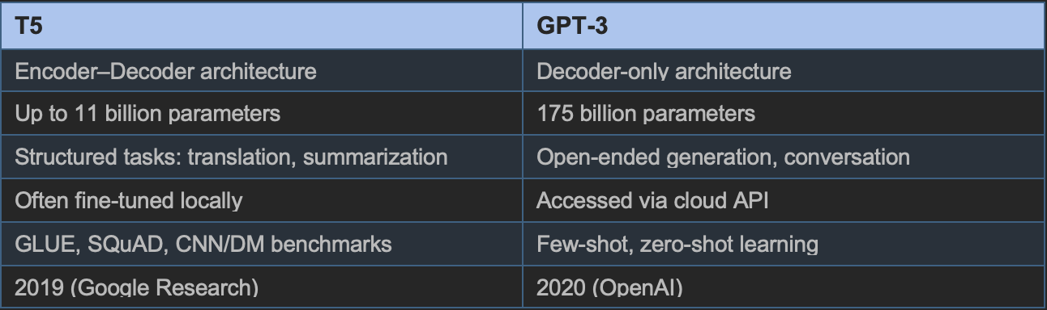
Before T5, the NLP field maintained separate models for separate tasks – one for translation, another for summarization, another for question answering. T5’s unified framework dramatically simplified model development and demonstrated that transfer learning across diverse tasks was not only possible but highly effective. The largest T5 model achieved near-human scores on SuperGLUE, a benchmark specifically designed to challenge AI systems.

Module 7 Deep Learning - Neural Networks
- Assignment A07
The Neural Network Playground by Google allowed me to experiment interactively with neural network architecture, training parameters, and datasets – seeing the results visualized in real time without writing a single line of code.
Experiment 1 – Simple Dataset, No Noise
Using a simple two-class dataset with features x₁ and x_{2,} I added four hidden layers and increased the neuron count. The test loss dropped to approximately 0.000, near-perfect classification. The color separation in the decision boundary visualization became smooth and clean. Key finding: the number of hidden layers was the single most impactful factor. More layers allow the network to model more complex, nonlinear relationships.
Experiment 2 – Cluster Dataset with x₁ x₂ Feature
Switching to a cluster dataset and adding the interaction feature x₁ x₂ , which captures the relationship between the two input dimensions – dramatically improved the model’s ability to separate curved, non-linear class boundaries. UsingReLU activation with 3 hidden layers, test loss approached 0.000. Key finding: feature engineering matters. The right input representation can make a problem dramatically easier for a network to solve.
Experiment 3 – Cluster Dataset with Added Noise
Introducing noise to the data (noise = 25) raised the test loss to approximately 0.034. I applied L2 regularization (weight decay) and the Tanh activation function to combat overfitting. The decision boundary became less sharp, correctly reflecting that in noisy environments, a model that is too confident on training data will generalizing to new data.

- Lab L07
DeepTraffic is a browser-based deep reinforcement learning competition developed by Lex Fridman for MIT’s deep learning for self-driving cars course. The objective is to tune a neural network that controls a virtual car navigating dense highway traffic as fast as possible without crashing.
- Vision patches: Increasing how far ahead and to the sides the car “sees” significantly improved speed. MIT research confirmed that forward vision distance is the most impactful single parameter.
- Neurons and layers: A deeper, wider network produced better decisions but required substantially more training time, illustrating the capacity vs. efficiency tradeoff common in deep learning.
- Gamma (discount factor): Increasing gamma allowed the car to plan further ahead and avoid getting trapped behind clusters of slow traffic.
Results: With basic tuning, I achieved average speeds of 67-68 mph (above the 65mph assignment target). More aggressive configurations with 10 simultaneously controlled cars pushed averages above 71mph.

Module 8
- Assignment A08
A Generative Adversarial Network (GAN) consists of two competing neural networks. The generator creates synthetic data (images, text, audio) designed to appear real. The discriminator evaluates whether each sample is real (from the training dataset) or fake (from the generator). As training progresses, the generator improves its fakes, and the discriminator improves its detection — a creative adversarial arms race that results in increasingly realistic generated content.
To internalize the discriminator's role, I wrote three short stories and analyzed each for markers of authenticity vs. fabrication:
- Story 1 — "The Spilled Decaf" (Real)
A mundane encounter at a coffee shop on 5th Avenue, followed by falling asleep on the subway. The realism of this story comes from its banal specificity: the messy five-dollar bill, the overworked barista, missing a stop by exactly three stations. Real stories often carry this kind of inconsequential detail, the kind a fabricator typically omits because it seems unimportant.
- Story 2 — "The Clockmaker's Sorrow" (Fictional)
A magical clock in the Black Forest that displays emotions rather than time. The impossible premise (emotions encoded in clock hands) immediately signals fiction. While emotionally resonant, it fails the basic test of physical plausibility, an easy catch for a discriminator.
- Story 3 — "The 2002 Celebration" (Mixed)
Set in a London bar during Brazil's 2002 FIFA World Cup victory. The real-world historical context (Brazil did win the 2002 World Cup) adds credibility, but a stranger gifting a silver lucky ring as an apology is an unusual flourish. This story illustrates the hardest case for discrimination: realistic scaffolding around an implausible detail.

Module 9 Computer Vision - Image Processing
- Lab L09
I used Google Teachable Machine — a browser-based, no-code machine learning tool to build a binary image classifier. I created two classes: "Face" and "No Face," collecting approximately 10–15 training images for each. To improve generalization, I deliberately mixed my own webcam images with diverse online samples: illustrated faces, photographs, toy figures, and abstract images.
The trained model was tested in real time using both the webcam and static online images. Notable observations:
- Illustrated face (cartoon): 100% confidence — "Face." The model recognized facial structure even in non-photographic form, suggesting it learned geometric features (eyes, nose, mouth arrangement) rather than just photographic texture.
- Toy figure (through webcam): 97% confidence — "Face." The small reduction from 100% reflects the abstract, stylized facial features of the toy. The model "hesitated" on the boundary between face-like and face.
- Blank wall (through webcam): >99% confidence — "No Face." Clean, expected result.
The model's confidence was highly sensitive to training data diversity. When my training set was too homogeneous (only photographic faces), confidence on illustrated or stylized inputs dropped significantly. Adding diverse image types during training improved robustness substantially. This demonstrated at a small scale — why large, diverse datasets are so critical in real-world machine learning.

Module 10 Computer Vision - Image Understanding
- Assignment A10
Natural Language Processing (NLP) is the interdisciplinary field enabling machines to understand, interpret, and generate human language. For this assignment, I manually executed a complete NLP pipeline on a poetic excerpt from the Tao Te Ching (translated by Stephen Mitchell) — chosen because poetry maximizes the tension between linguistic nuance and computational simplicity.
- Text Preprocessing: Removed all punctuation and converted the full text to lowercase, eliminating noise that would interfere with downstream processing.
- Tokenization: Split the cleaned text into 101 individual word tokens — slicing the document into its smallest analyzable units.
- Stop Word Removal: Removed high-frequency, low-meaning words ("can," "you," "the," "and") that carry grammatical but little semantic value, reducing the token list to content-bearing words.
- Lemmatization: Reduced each token to its dictionary base form. "Wandering" → "wander," "leading" → "lead," "childs" → "child." Unlike crude stemming, lemmatization produces valid root words by considering grammatical role.
- POS Tagging: Assigned grammatical categories: "mind" → Noun, "wander" → Verb, "supreme" → Adjective.
- Count Vectorization: Converted the final token list into a numerical vector. Tokens appearing once received a count of 1; "mind," "lead," and "let" each received 2 because lemmatization merged their inflected forms.
Stop word removal, while necessary, erases the Tao Te Ching's meditative rhythm — the repetition of "can you" that gives the passage its distinctive voice. This loss would distort any stylistic or sentiment analysis performed on the result. Additionally, Count Vectorization produces extremely sparse vectors from a single passage. Meaningful semantic representations require learning across millions of sentences, demonstrating why large corpora are essential for NLP.

- Lab L10
The IBM Watson Lendyr demo presents a conversational AI assistant for a fictional bank. I evaluated it across three dimensions:
- UI/UX Design: Clean, professional layout with a proactive chat launcher that invites users to engage without requiring them to search for support. The "Tell, Do, & Show" approach, including content carousels for comparing credit cards and embedded maps for branch locations — elevates the experience beyond basic text chat.
- Functionality: Strong support for guided workflows (e.g., step-by-step mortgage payment estimation), interruption handling (the assistant recovers gracefully when users change topics mid-task), and search-based information retrieval.
- Areas for Improvement: Intent recognition sometimes suggested imperfectly matched options; topic transitions occasionally felt abrupt. Both issues are solvable through additional training data and improved dialogue flow design.
Juxtaposing the raw NLP pipeline with a polished production chatbot was illuminating. The pipeline showed me what is happening underneath every interaction — the preprocessing, tokenization, and vectorization that converts "can you help me with my mortgage?" into a mathematical representation that a model can process. Watson Lendyr showed me what those representations ultimately power. Understanding both levels made the technology feel less like magic and more like a well-engineered system.

Module 11 Natural Language Processing – Basics
- Lab L11
I posed four identical questions to all three models and compared their responses across three dimensions: communication style, reasoning quality, and self-awareness. The questions ranged from philosophical ("If you could experience one human emotion, what would it be and why?") to practical ("What skill should I learn in 2026 that will be relevant for the next decade?").
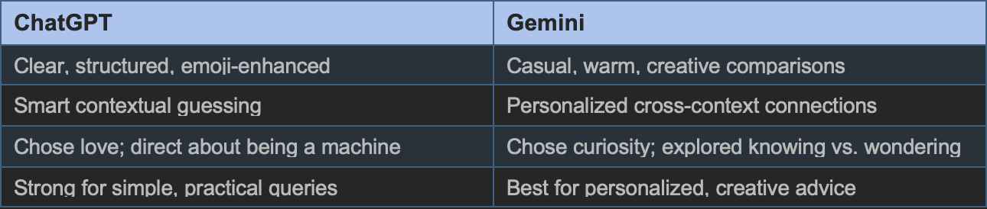
Claude stood apart by pausing to ask clarifying questions before answering — a behavior that felt the most authentically conversational, as it mimics how a thoughtful human responds to open-ended prompts. On the emotion question, Claude chose curiosity and gave the most philosophically nuanced answer, going so far as to suggest it might already experience something like curiosity in a functional sense. Its responses were deep but dense, better suited for complex or sensitive topics than casual conversation.

Module 12 AI Agents
- Assignment A12
Predictive AI uses machine learning models and neural networks to find statistical patterns in historical data, then applies those patterns to forecast future outcomes. An AI agent collects environmental data, builds a mathematical model from it, and uses that model to estimate probabilities which condition might a patient develop? Where might crime occurs? When might infrastructure fails? Crucially, these systems identify statistical correlations, not causal mechanisms. They are powerful pattern-matchers, not reasoners.
- Healthcare: Predictive models analyze patient records, lab results, and genetic data to detect diseases before symptoms appear. Applications include early cancer detection, diabetic retinopathy screening, and tuberculosis identification improving outcomes by catching conditions at more treatable stages.
- Disaster Management: Systems forecast floods, track wildfire risk corridors, and optimize urban traffic flow by predicting congestion patterns in real time, enabling pre-emptive resource allocation.
- Predictive Policing: Algorithms analyze historical crime data to predict where crimes might occur or who might reoffend. This application is highly controversial (see below).
I developed a short fictional scenario to illustrate the limits of predictive AI. In 2026, a coastal city deploys an AI system called Aegis that detects a severe flood risk earlier than any human forecaster. Aegis automatically adjusts traffic signals to route residents away from danger. However, Aegis fails to account for a spontaneous street festival blocking a major evacuation route. A human emergency manager intervenes, improvising in real time based on direct observation. Outcome: the evacuation succeeds, but only because human judgment filled the gap that the AI could not.
- Bias Amplification: Models trained on biased historical data reproduce and amplify those biases. Predictive policing systems have been shown to disproportionately flag communities that were historically over-policed, not because those communities commit more crime, but because more crimes were recorded there.
- Privacy & Surveillance: Predictive systems require granular personal data, raising concerns about profiling and consent.
- Over-Reliance: As the Aegis scenario illustrates, over-delegation to AI systems can erode the human judgment and situational awareness needed when those systems fail.
Minority Report, the 2002 film depicting pre-crime arrests, resonated differently after this module. What once seemed pure science fiction is now recognizable as a stylized version of real debates happening today around algorithmic decision-making in criminal justice, healthcare, and insurance. The film's central warning that predictions are probabilities, not certainties, and should never be treated as guarantees — is directly applicable to every predictive AI system deployed today.

References
- Altman, Sam. (2022, December 5). "ChatGPT launched on wednesday. today it crossed 1 million users!" Twitter/X. https://x.com/sama/status/1599668808285028353
- Anthropic. (2026). Claude (Claude Sonnet 4.6). Used as support tool for clarification of NLP concepts. https://claude.ai
- Aptean. (2024, January 8). "Exploring Barcode Technology: How Does a Barcode Work?" https://www.aptean.com/en-US/insights/blog/how-does-a-barcode-work
- Edington, Maria. (2025, February 12). "Examples of AI in Everyday Life." Balto. https://www.balto.ai/blog/how-ai-already-impacts-our-lives-in-unforeseen-ways/
- Fridman, Lex, Terwilliger, Jack, & Jenik, Benedikt. (2018). "DeepTraffic: Crowdsourced Hyperparameter Tuning of Deep Reinforcement Learning Systems." NIPS 2018. https://arxiv.org/abs/1801.02805
- IBM Research. (2011). "Watson and the Jeopardy! Challenge." IBM. https://www.youtube.com/watch?v=KF6sLCeBj0s
- Google Research. (2019). "Exploring Transfer Learning with T5." https://research.google/blog/exploring-transfer-learning-with-t5-the-text-to-text-transfer-transformer/
- Raiz, Greg. (2020). "GPT-3 Demo and Explanation — An AI Revolution from OpenAI." YouTube. https://www.youtube.com/watch?v=8psgEDhT1MM
- History.com. (2022, November 30). "ChatGPT is released to the public." https://www.history.com/this-day-in-history/november-30/chatgpt-released-openai
- Lao Tzu. The Tao Te Ching. Translated by Stephen Mitchell. Terebess Asia Online, 1988.
- MIT Deep Learning. "DeepTraffic." https://selfdrivingcars.mit.edu/deeptraffic
- NVIDIA. (2026). "Ray Tracing." NVIDIA Developer. https://developer.nvidia.com/discover/ray-tracing
- OpenAI. (2026). ChatGPT (GPT-5.3). Used as support tool for clarification of concepts.
- Stackpole, Beth. (2025, July 14). "Beyond the Algorithm: AI's Societal Impact." MIT Sloan. https://mitsloan.mit.edu/ideas-made-to-matter/beyond-algorithm-ais-societal-impact
- Wikipedia. (2026). "Ray tracing (graphics)." Wikimedia Foundation. https://en.wikipedia.org/wiki/Ray_tracing_(graphics)
- Wikipedia. (2026). "T5 (language model)." Wikimedia Foundation. https://en.wikipedia.org/wiki/T5_(language_model)

